RETRIVING DATA USING SELECT STATEMENT
QUESTION :1

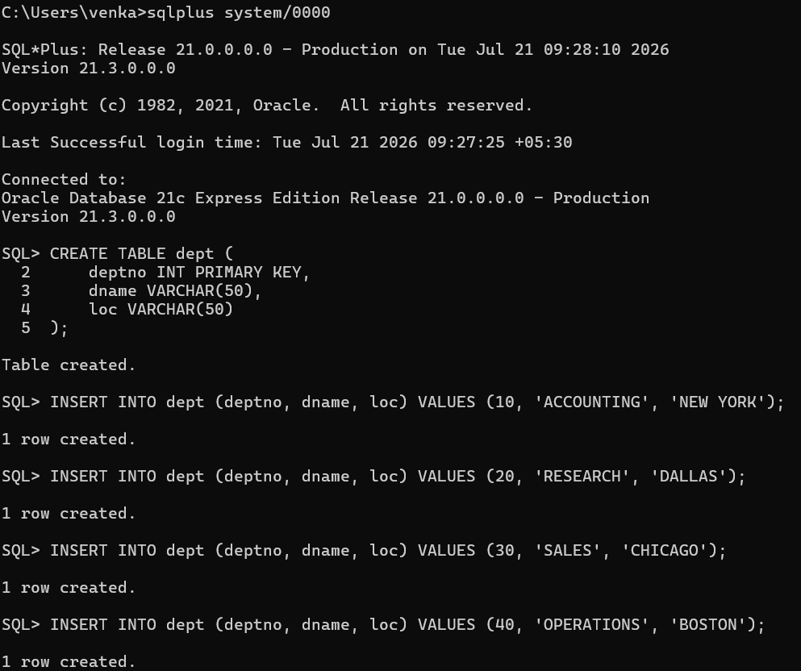determine the structure of the dept table and its contents

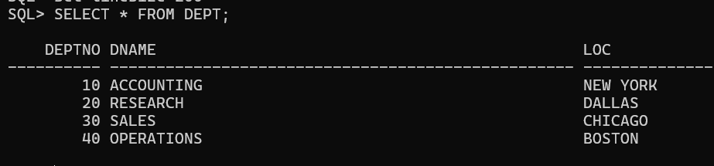

2. determine the structure of the emp table and its contents
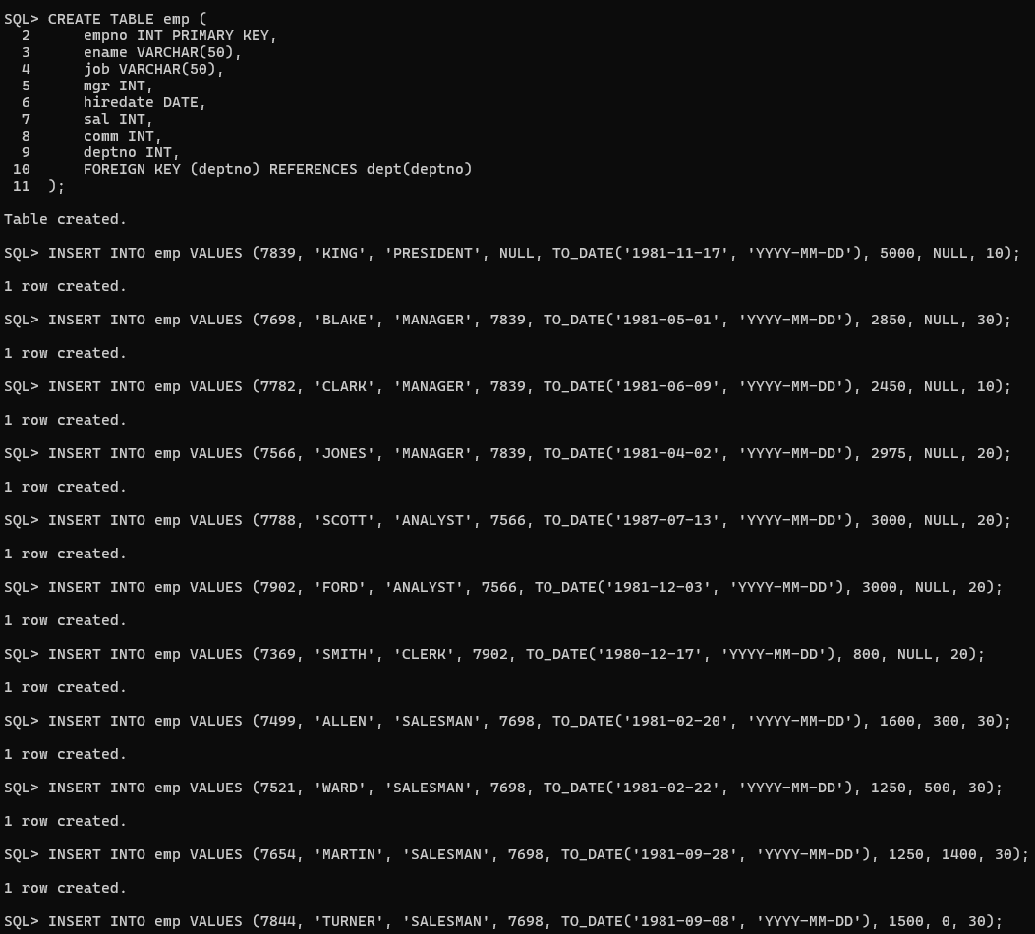
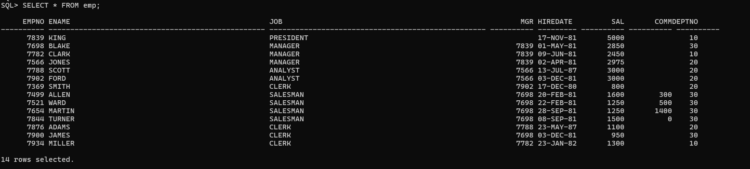

3. diplay the empno and dept number from employee table whose employee number is 7788
